**Hair fall and Scalp Disease Detection Using Deep Learning and AI**

Hira Farman, Saad Ahmed, Jaish Kadiwal, Usman Saleem, Hamood Ahmed,

Laiba Binte Ovais

Department of Computer Science

Iqra University, Karachi, Pakistan

Corresponding Author: Email: [hira.farman@iqra.edu.pk](mailto:hira.farman@iqra.edu.pk)

**Abstract**

Hair fall analysis is highly complex due to its unusual nature and varing environmental and genetic factors. It has always been a challengeable work for dermatologists and researchers in the field. In various studies for hair fall detection,several Machine Learning (ML) and Data Mining methods have been used,giving improved accuracy in predictions.It Discuss how advancements in AI and deep learning can revolutionize dermatology and trichology (the study of hair and scalp disorders).It includes statistics or case studies showing the future impact of AI in medical imaging and diagnostics.This study employs with a deep learning technique to analyze hair fall data, applying several deep learning methods for prediction, such as Convolutional Neural Network (CNN), Simple Recurrent Neural Network (RNN), Long Short-Term Memory (LSTM) and Artificial Neural Network (ANN). A modified study of these techniques for hair fall detection is presented, with the performance of each method evaluated using the Mean Absolute Percentage Error (MAPE%) and Root Mean Squared Error (RMSE%). The results demonstrate that the RNN model with tanh activation outperforms the others, showing the best prediction performance with the lowest MAPE% and RMSE%, making it the most effective model for hair fall prediction in this study.

**Keywords**

Hairfall Prediction, Scalp Disease Detection Using Deep Learning, Convolutional Neural Networks (CNN),ANN, Recurrent Neural Networks (RNNs),LongShort-TermMemory.

* **Introduction**

Hair fall prediction can contribute significantly to helping individuals make sophisticated decisions regarding hair care, treatment options, and overall health. Factors such as genetics, hormonal imbalances, nutritional deficiencies, stress, and environmental conditions significantly impact hair health. In particular, hair care and treatment industries benefit from accurate hair fall predictions, as they enable better product development and customized treatment plans.Hair loss affects over 80 million individuals in the U.S, essentially due to aging, stress, medication, or genetics. Early diagnosis is often delayed due to dependence on professional dermatologists and costly tests. Deep learning techniques like convolutional neural networks (CNNs) enable early detection of scalp conditions, making the process more available and effective [2].A System for Scalp Health Diagnosis and Inspection Based on Machine Learning which provides poor daily habits often result in common scalp problems such as greasy hair, folliculitis, dandruff, and hair loss. AI-based techniques, particularly machine learning (ML), allows for exact categorization of scalp damage and healthy hair,providing a productive approach to early detection of hair loss.Similarly, early prediction of hair fall is crucial. It helps individuals take protective measures, make informed decisions about hair care and treatment, and even avoid advanced stages of hair damage [3].Alopecia Areata (AA) prediction with machine learning methods provides a dataset of 1,000 images of healthy hair that are collected through web scraping, along with the Figaro 1k dataset. The research utilizes SVM, KNN, and CNN algorithms, highlighting the importance of computer-aided diagnosis in improving the accuracy of AA prediction and classification.Today, artificial intelligence techniques are increasingly used for data analysis and prediction across different fields, including hair and scalp health. In various studies for hair fall various Data Mining and Machine Learning (ML) approaches have been used for prediction that are applied, resulting in improved accuracy. In this study, a deep learning methodology was employed to analyze hair loss data. Deep learning beat at handling large datasets and complex patterns [4].

* Problem Statement

The primary objective of the problem-solving approach is to develop an advanced AI and deep learning-based system for detecting hair fall and scalp diseases to improve the precision of diagnosing hair fall and various scalp diseases by leveraging advanced deep learning models, to streamline the diagnostic process, reducing the need for manual interference and increasing the workflow and offer detailed and actionable insights based on the analysis, enabling timely and appropriate treatment decisions. Hair fall can be caused by a variety of factors, including genetic, environmental, and medical conditions, leading to diverse patterns and symptoms. Scalp diseases include a range of conditions such as dandruff, psoriasis, eczema, and fungal infections, each with distinct symptoms.The aim of this study is to provide advanced AI and deep learning techniques to increase the accuracy of detecting specific conditions and their severity and automate the analysis of images and data to reduce manual effort and improve the efficiency of the diagnostic process.The Detection of Hairfall is possible by creating a deep learning model that can analyze scalp images.

* What is Hairfall?

HairFall, sometimes referred to as baldness or alopecia,directs to a hair loss resulting from part of the head. Typical varieties consist of male-or alopecia areata, hair loss with a feminine pattern,and a hair thinning is referred to as [telogeneffluvium.](https://en.wikipedia.org/wiki/Telogen_effluvium)An Ordinal Logistic Regression,the study gives the behavioral factors to FPHL(Female Pattern Hair Loss) seriousness and suggests avoiding alcohol, ponytails, and improving sleep may prevent worsening [28]. Evaluation of Patients with Alopecia the research mention the precise tools for diagnosing and determining alopecia, including structured interviews, questionnaires, and clinical examinations [32].

* Research Questions
* How productive are deep learning models in detecting different types of hair fall and scalp diseases compared to standard diagnostic methods?
* What deep learning architectures (e.g., CNNs, transfer learning models) submit the best results for detecting hair fall and scalp conditions from image data?
* How does the quality and different training data impact the performance of deep learning models for detecting scalp diseases?
* **Related Work**

The Hair Loss Severity Estimation using Mask R-CNN proposes an intelligent system using multitask learning with Mask R-CNN to detect and restrict hair follicles while evaluating hair loss severity in microscopic images. The images are categorized into three classes: healthy, normal, and severe. Artificial Neural Network (ANN) for repeated hair fall prediction. These techniques were applied for hair loss detection in different scalp conditions [1**].**A prediction of Alopecia Areata using CNN.It presents a novel CNN architecture designed for efficient detection using an image dataset. The Alopecia Areata terrible autoimmune disease that leads to hair damage, brittle nails, and bald spots, was analyzed with CNN, achieving 98% accuracy on the dataset.This developed a model to predict hair loss severity based on scalp health data. The dataset was collected from dermatological clinics and included factors such as scalp texture, hair density, follicle health, hormone levels, and environmental conditions [5].

Hair Loss Stage Prediction Using Deep Learning.A convolutional neural network (CNN) was implemented to predict hair loss stages based on practical grouping.This study shows that deep learning can freely identify hair loss stages from frontal scalp images, contributing to advancements in early diagnosis and personalized treatment. This hybrid system was applied to predict the development of hair loss for up to 7 stages ahead. The system achieved an accuracy of 94% [6].An calculation of Automated Measurement of Hair Density Using Deep Neural Networks that focuses on automating Hair Density Measurement (HDM) object detection using deep neural networks. The dataset comprised 4,492 RGB images of male hair-loss patients, explained with detailed hair follicle locations and types for accurate analysis [7].

Intelligent Healthcare Platform for Diagnosis of Scalp and Hair Disorders which explores three deep learning models— ResNet-152, Net B-6, and ViT-B/16 focused at enabling objective tracking and early diagnosis of scalp and hair disorders using advanced deep learning techniques.It highlights the effectiveness of data-driven approaches in understanding hair loss patterns and achieving an accuracy of 70% [8].Hair and Scalp Disease Detection Using Deep Learning which focuses on integrating machine learning into web applications to enhance patient diagnosis and treatment. It aims to emphasize the evolving impact of technology on the future of healthcare and patient management.A deep convolutional CNN, or neural network, was employed for this forecast [10].

An Intelligent Hair and Scalp Analysis System Using Camera Sensors and the Norwood-Hamilton Model that employs webcam and microscope sensors to assess hair and scalp health through detailed feature images. By utilizing a deep learning model, the system achieves an accuracy of 90% in evaluating hair loss and scalp conditions [11].Deep Learning-Based Detection of Hair Loss Levels from Facial Images that presents a training dataset featuring varying levels of baldness for automatic classification of facial images using a proposed matching method. The study analyzed four parameters: Hair Density, Follicle Size, Scalp Condition, and Age, for accurate hair loss prediction. The prediction accuracy was measured using metrics such as Error Squared Root Mean (RMSE) and a matrix of confusion [12].

The Prediction of Hair Fall Patterns in a Person Using Artificial Intelligence for Better Care and Treatment which presents AI methods to predict hair loss patterns associated with Alopecia Areata and Telogen Effluvium by applying deep learning algorithms, achieving an accuracy of 85% [13].Survey-Based Machine Learning Approaches to Diagnose Hair Fall Disorder in the Bangladeshi Community which discusses various machine learning techniques, such as Random Forest, K-Nearest Neighbors (KNN), and Support Vector Machine (SVM),deployed to evaluate accuracy while analyzing datasets related to hair fall disorders. The performance was estimated using metrics such as F-measure, accuracy, precision, and recall, and it achieved a prediction accuracy of 89.54%, highlighting its effectiveness in diagnosing hair fall disorders [14].

An Analysis of Alopecia Areata Classification Framework for Human Hair Loss Based on VGG-SVM Approach that proposes a framework for evaluating neural networks to recognize alopecia and non-alopecia conditions, classifying healthy hair and alopecia using a dual-model approach. The VGG-19 model is employed for feature extraction, followed by Support Vector Machine (SVM) to construct a machine learning model utilizing 70% of the image dataset [23].Machine Learning on Classification of Healthy and Unhealthy Hair which addresses concerns regarding the usefulness and reliability of deep learning models in critical applications, such as medical diagnostics, while achieving an impressive accuracy of 96.63% [24].

A Healthy Scalp Inspection and Diagnosis System Using Multiple of Deep Learning-Based Modules which presents a novel multimodal deep learning-oriented system for diagnosing and inspecting the scalp, utilizing AI-driven object recognition techniques to enhance diagnostic accuracy [25].Trichoscopic Features in Female Pattern Hair Loss: A 1-Year Hospital- Based Cross-Sectional Study that illustrates the trichoscopy can effectively diagnose early Female Pattern Hair Loss (FPHL) and differentiate it from other conditions, even in the absence of hormonal investigations. By integrating AI and deep learning models, the need for huge scalp examinations is significantly reduced [27].Trichoscopic features in female pattern hair loss: 1-Year hospital-based cross-sectional study,it provides that while lacking hormonal investigations, trichoscopy can successfully diagnose early FPHL(Female Pattern Hair Loss) and differentiate it from other conditions, reducing the need for scalp checkup.[28]Effect of Behavioral Factors on Severity of Female Pattern Hair Loss: An Ordinal Logistic Regression Analysis,the paper gives the behavioral factors to FPHL(Female Pattern Hair Loss) seriousness and suggests avoiding alcohol, ponytails, and improving sleep may prevent worsening.[29]

A quantitative classification for androgenetic alopecia and its application to hair transplantation,the paper provides a new numerical PRECISE scale for classifying (Androgenetic Alopecia)AGA with subjective methods, recommending 1500 follicular units per score for hair transplantation to improve results.[30]

Hair Transplantation in the United States: A Population-based Survey of Female and Male Pattern Baldness,the paper gives the details that Americans see hair loss as a major issue and value hair transplantation, but more affordable, gender-specific options and public opinions on HT(Hair Transplantation) needs more analysis.[31]Types of hairline recession in androgenetic alopecia and perceptions of aging in Asian males,the paper mentions the Cranial hair loss is connected to aging and affects age perception in Western males, but the impact of hairline slowdown in individuals with PFA(Perceived Facial Age) is not well known.[32]Evaluation of Patients with Alopecia,the paper highlights the need for refined, precise tools for diagnosing and determining alopecia, including structured interviews, questionnaires, and clinical examinations.[33]

Association of Hair Loss With Health Utility Measurements Before and After Hair Transplant Surgery in Men and Women,the paper shows that hair transplant surgery improves health utility scores for androgenetic alopecia in both men and women compared to unfinished cases.[34]Power of Molecule on Hair Growth A Clinical Study,this learning mentions that Hair follicles produce keratin, the main protein in hair. Regular use of hair serum with NX35 growth molecule improves hair density, volume, and thickness, labeling hair loss affecting 50% of men and 15–30% of women factors.[35]Hair loss among transgender and gender‐nonbinary patients: a cross‐sectional study,it gives the study to examine how gender-state hormones impact scalp hair loss, underlining the need for personalized diagnosis and treatment. MHT(Masculinizing Hormone Therapy) uses testosterone for male features, while FHT(Feminizing Hormone Therapy) uses estrogen and antiandrogens for female features.[36]The reliability of horizontally sectioned scalp biopsies in the diagnosis of chronic diffuse telogen hair loss in men,the paper provides the Understanding of male pattern baldness that is critical for successful hair transplant surgery, which depends on proper patient selection and good results of Hair Transplantation.[37]Classification of the types of androgenetic alopecia (common baldness) occurring in the female,the paper gives the categorization of female androgenetic alopecia phases which is presented to enable early diagnosis and treatment with antiandrogens.[38]

A New Classification of Male Pattern Baldness and a Clinical Study of the Anterior Hairline,the paper provides the baselines for hair restoration by identifying six types of male pattern baldness and highlights the need for systematic measurements of hairline structures.[39] The prevalence and types of androgenetic alopecia in Korean men and women,the paper mentions that 48.5% of men and 45.2% of women have a family history of baldness, Type III vertex connection is most common between ages 30-70, with type VI existing after 70. Korean men often have more frontal hairline sustaining and a female patternis seen in 11.1% of cases. The commonness of AGA Androgenetic Alopecia (Norwood III or above) in Korean men is 14.1%.[40]

Trichoscopic Patterns of Nonscarring Alopecia's, the paper givesa study group with a mean age of 26, trichoscopy discloses common features such as broken hair and black dots (48% each), and honeycomb pigmentation (26%). Alopecia areata (AA) is more frequent in males (41.8%), while females are uniformly affected by AA and female pattern hair loss (29.8%). Early diagnosis and treatment of hair loss, a major cause of psychological stress, are critical.[41]

This Paper provides the information about Hair and Scalp Disease Detection Using Machine Learning and Image Processing,80 million Americans suffer from hair loss due to aging, stress, medication, or genetics.[42]The hair-related diseases when diagnosing often faces delays due to the need for professional dermatologists and medical tests.After applying convolutional neural networks (CNNs) validates early-stage detection.[43]The Learning gives the details of Machine Learning-Based Scalp Hair Inspection and Diagnosis System for Scalp Health.Poor daily habits lead to common scalp and hair issues like dandruff, folliculitis, hair loss, and oily hair.ML-based techniques enable accurate classification of healthy hair and damaged scalp, offering an effective solution for detecting hair loss.[44]

It presents the Prediction of Alopecia Areata using Machine Learning Techniques.A dataset of 1,000 images of healthy hairs are collected through web scraping and the Figaro 1k dataset.This research paper uses SVM, KNN,and CNN algorithms.This study highlights the importance of computer-aided diagnosis in improving the accuracy of AA prediction and classification.[45]A Prediction of Alopecia Areata using CNN.The study direct to present a novel CNN architecture for efficient detection using an image dataset.Alopecia Areata, a chronic autoimmune disease causing hair damage, brittle nails, and bald spots CNN perform 98% accuracy while working on the dataset.[46]Hair Loss Stage Prediction Using In-depth Education.A neural network that is convolutional (CNN) is implemented to predict hair loss categories practically.This research shows that deep learning can automatically identify hair loss stages from frontal photos,training to advance diagnosis and treatment.[47]An Evaluation of Automated Measurement of Hair Density Using Deep Neural Networks.The Knowledge makes the research for automating HDM object detection.The dataset included 4,492 RGB images of male hair-loss patients,that are explained with hair follicle locations and types.[48]

Intelligent Healthcare Platform for Diagnosis of Scalp and Hair Disorders.The understanding gives the research of three deep Learning Models ResNet-152,Net B-6 and Vit-B/16.This aims to enable the objective monitoring and early diagnosis of scalp issues using deep learning models.[49]Pre-trained classification of scalp conditions using image processing.The Research Paper manages SVM (Support Vector Machine) which classifies alopecia areata and normal scalp conditions from 120 images.This study aims to quickly categorize scalp conditions and suggest suitable treatments.Hair and scalp disease detection using deep learning,this study leads to Integrating machine learning into web applications to transform patients and strength.This aims to highlight the changing impact of technology on the future of healthcare and patient care.[50]

* **Comparative Analysis of Past Studies for Hairfall Detection Using AI and Machine Learning.**

This table sum up the key elements of a comparative study by country, year, algorithms, datasets, target features, accuracy and limitation of models.

* SOURCE TABLE

Table-3 presents a carefully selected group of literature that shows the development of a deep learning model for recognizing scalp diseases and hair loss. These sources provide valuable understanding of many machine learning and image processing approaches related to scalp health, featuring both advanced deep learning frameworks and traditional techniques. The overview highlight the connection of these studies for the hair loss detection using AI, machine learning and deep learning.

**Table 1: Source Table**

|  |  |  |
| --- | --- | --- |
| **S.No** | **Source**  **No.** | **Source Name** |
| S1 | [1] | “To classify hair follicles and estimate hair loss severity using CNN and Mask R-CNN”. |
| S2 | [2] | “To detect hair and scalp diseases using machine learning using Deep learning with CNN”. |
| S3 | [3] | “Early Alopecia Detection with Two-layer feed-forward network with backpropagation”. |
| S4 | [4] | “To explore the advancements in deep learning for diagnosing scalp diseases with the integration of CNN and FCN for diagnosis.”. |
| S5 | [5] | “To classify healthy hair and alopecia areata using machine learning”. |
| S6 | [6] | “Hair Follicle Classification and Hair Loss Severity Estimation Using Mask R-CNN,CNN”. |
| S7 | [7] | “Hair and Scalp Disease Detection using Machine Learning and Image ProcessingAlgorithms are used”. |
| S8 | [8] | “A Machine Learning-Based Scalp Hair Inspection and Diagnosis System for Scalp Health”. |
| S9 | [9] | “Pre-trained classification for scalp conditions using image processing SVM Model and  Algorithms are used”. |
| S10 | [10] | “Hair and scalp disease detection using deep learning CNN Networks Algorithms are Used”. |
| S11 | [11] | “An intelligent hair and scalp monitoring system using camera sensors and Norwood-Hamilton  model. Webcam, Sensors and Deep Learning Algorithms are used”. |
| S12 | [12] | “Deep Learning based detecting of Hair Loss Levels from Facial Images Deep Learning Methods and Algorithms are applied”. |

**Table 2. SLR Table**

|  |  |  |  |  |  |  |  |
| --- | --- | --- | --- | --- | --- | --- | --- |
| S.NO | STUDY | PURPOSE / OBJECTIVE | METHODOLOGY | KEY FINDINDS | GAPS / LIMITATION | RESEARCH PAPER LINK | RELEVENCE TO YOUR RESEARCH PAPER |
| 1. | Paper on CNN and Mask R-CNN (2024) | |  | | --- | | To classify hair follicles and estimate hair loss severity. |  |  | | --- | |  | | |  | | --- | | Utilized ResNet-50 and ResNet-101 with Mask R-CNN. |  |  | | --- | |  | | |  | | --- | | ResNet-50 had higher misclassification rates than ResNet-101. |  |  | | --- | |  | | |  | | --- | | Focuses primarily on accuracy; does not explore user interface or practical application. |  |  | | --- | |  | | **https://www.mdpi.com/2313-433X/8/10/283** | |  | | --- | | Supports the application of CNN and Mask R-CNN in dermatology. |  |  | | --- | |  | |
| 2. | Paper on Hair and Scalp Disease (2024) | |  | | --- | | To detect hair and scalp diseases using machine learning. |  |  | | --- | |  | | |  | | --- | | Deep learning with CNN for scalp disease detection. |  |  | | --- | |  | | |  | | --- | | Achieved 96.2% training accuracy, and 91.1% validation accuracy Identifying diseases accurately. |  |  | | --- | |  | | |  | | --- | | Limited datasets hinder the generalizability of findings. |  |  | | --- | |  | | [**https://www.researchgate.net/publication/366821677_Hair_and_Scalp_Disease_Detection_using_Machine_Learning_and_Image_Processing**](https://www.researchgate.net/publication/366821677_Hair_and_Scalp_Disease_Detection_using_Machine_Learning_and_Image_Processing) | |  | | --- | | Directly relevant for developing scalp diseases detection systems. |  |  | | --- | |  | |
| 3. | |  | | --- | | Early Alopecia Detection Study (2023) |  |  | | --- | |  | | |  | | --- | | To propose a model for early detection of alopecia. |  |  | | --- | |  | | |  | | --- | | Two-layer feed-forward network with backpropagation. |  |  | | --- | |  | | |  | | --- | | Achieved 91% training accuracy using 100 samples. |  |  | | --- | |  | | |  | | --- | | Limited sample size; focus on only one type of hair disease. |  |  | | --- | |  | | **https://www.semanticscholar.org/reader/9317eb761d51f6eb428a157a02e2114a90b409e4** | Provides a foundation for improving early detection techniques. |
| 4. | Research on Deep Learning Advances (2023) | |  | | --- | | To explore the advancements in deep learning for diagnosing scalp diseases. |  |  | | --- | |  | | |  | | --- | | Reviewed the integration of CNN and FCN for diagnosis. |  |  | | --- | |  | | |  | | --- | | Improved diagnostic capabilities due to advancements in computation and computer vision. |  |  | | --- | |  | | |  | | --- | | Highlights the need for further research and improvements in deep learning applications. |  |  | | --- | |  | | **https://www.semanticscholar.org/reader/70de3b1b4a209bd48176a1675a188f0491cc9395** | Supports the ongoing development of AI-driven diagnostic tools for scalp health. |
| 5. | |  | | --- | | Study on Hair & Scalp Disease (2021) |  |  | | --- | |  | | |  | | --- | | To classify healthy hair and alopecia areata using machine learning. |  |  | | --- | |  | | |  | | --- | | Implemented a machine learning classification framework. |  |  | | --- | |  | | |  | | --- | | Developed a model with a focus on specific hair conditions, reporting high accuracy. |  |  | | --- | |  | | |  | | --- | | The framework may not cover other scalp conditions comprehensively. |  |  | | --- | |  | | **https://ijsrem.com/download/hair-scalp-disease-detection-using-machine-learning-image-processing/** | |  | | --- | | Highlights classification techniques relevant to hair diseases. |  |  | | --- | |  | |
| 6. | Hair Follicle Classification and Hair Loss Severity Estimation | The goal of the research study is to improve the diagnosis and categorization of scalp illnesses by creating a deep learning model with ResNet.  . | Features retrieved by ResNet, localized follicles using ROI alignment, density-based classification, and scores standardized across circumstances Making Use of Mask R-CNN  CNN | Overall, ResNet-50 outperformed ResNet-101 in misclassifying labels as severe, normal, and healthy. | The short sample size, lack of diversity, robustness problems, high computing demands, and interpretability issues are some of the study's weaknesses. | [**https://www.mdpi.com/2313-433X/8/10/283**](https://www.mdpi.com/2313-433X/8/10/283) | This study paper addresses issues of accuracy and improves clinical decision-making for scalp problems by utilizing deep learning to improve hair loss diagnosis. |
| 7. | The research focuses on using deep learning to diagnose folliculitis, psoriasis, and alopecia. | The aim of deep learning is to diagnose hair-related diseases more accurately and automatically. | Convolutional neural network (CNN) model was applied to the processing and analysis of a dataset including 150 scalp pictures. | The model achieved high accuracy (96.2% training accuracy and 91.1% validation accuracy) with precision and recall scores for alopecia, psoriasis, and folliculitis, suggesting efficacy. | Limitations include a small sample size, limitations in dataset variety, and minimal current research in this topic. | **https://www.researchgate.net/publication/366821677_Hair_and_Scalp_Disease_Detection_using_Machine_Learning_and_Image_Processing** | This work, which presents comparable approaches and difficulties, is in line with your focus on deep learning for the diagnosis of scalp diseases. |
| 8. | A Machine Learning-Based Scalp Hair Inspection and Diagnosis System for Scalp Health | Provide a precise way to distinguish between healthy hair and injured scalps.  . | Using pictures of both healthy and ill scalps, the VGG-19 model, a convolutional neural network (CNN), is used in this study to train and test the categorization of various hair conditions. | Using a machine learning algorithm linked to hair fall illnesses, it provides a 90% accurate categorization of healthy hair and damaged scalp. | Difficulties in acquiring a variety of datasets could impact the accuracy and generalizability of the model. | **https://www.researchgate.net/publication/379028404_A_Machine_Learning-Based_Scalp_Hair_Inspection_and_Diagnosis_System_for_Scalp_Health** | corresponds with your emphasis on the identification and categorization of scalp diseases using machine learning. |
| 21 | Quantitative analysis and development of alopecia areata classification frameworks | It provides the differences of two Optimized CNN’s with existing models for affected hair images. | CNN Model with the datasets of healthy hair images are applied for the analysis and classifying hair disease Alopecia Areata | While Applying CNN Algorithm, it provides 95% accuracy for identifying hair disease AA (Alopecia Areata). | It may not show the full range of Alopecia Areata changes and other hair conditions and while relying on one CNN Model should need to improve classification accuracy. | **https://www.semanticscholar.org/paper/Quantitative-analysis-and-development-of-alopecia-Dubey-Morales/fefcb4264e507d8c8114c3a4126d3f10aab247f5** | This indicates that the suggested algorithms like CNN provides an actual framework for Alopecia Areata Classification. |
| 40 | Scalp Disorder Diagnosis using Deep Learning and Machine Learning Methods | To create a method for diagnosing scalp diseases that combines machine learning and deep learning | CNN and ConvNet models used with SVM and KNN machine learning algorithms | The CNN-based model demonstrated an accuracy range of 97.41% to 99.09% for scalp diseases, whereas SVM and KNN demonstrated an accuracy range of 91.4% to 88.9% for the detection of alopecia. | Restricted to particular scalp conditions; additional effort is required for broader illness coverage | **https://www.semanticscholar.org/reader/70de3b1b4a209bd48176a1675a188f0491cc9395** | Very pertinent to your project's development of a deep learning model for identifying scalp conditions |
| 27 | A Cross-Sectional, Hospital-Based Study of Trichoscopic Features in Female Pattern Hair Loss Over One Year | To examine the relationship between the trichoscopic characteristics of female pattern hair loss (FPHL) and the degree of hair loss | Clinical and microscopic examination of 110 patients; results were compared with controls; 89% accuracy was achieved with deep learning and machine learning models. | It was discovered that trichoscopic characteristics such as hair diameter diversity, white spots, tiny scaling, and honeycomb coloring were important markers. | Only trichoscopic observations; lacks hormonal and histological analysis | **https://www.semanticscholar.org/paper/Trichoscopic-features-in-female-pattern-hair-loss%3A-Kothari-Patil/1b31524e931e02675caeeada34ffe5fe39642e83** | Similar to your project on scalp condition diagnosis, this one is pertinent to the use of trichoscopy and AI models for early hair loss detection. |
| 34 | | NX35growthTM Molecule's Effect on Hair Growth: A Clinical Investigation | Will conduct clinical trials to examine the NX35growthTM molecule's efficacy in hair growth | Hair density and thickness were analyzed using deep learning models, and data was gathered from 51 subjects utilizing the Aramo SG® ASG 200F for measurement. | With an accuracy of 85%, NX35growthTM serum improved hair density, volume, and thickness following 28 and 56 days of use. | Small participant numbers, no control group, and hazy long-term results | **https://www.semanticscholar.org/paper/Efficacy-of-NX35growthTM-Molecule-on-Hair-Growth-%3A-Y%C4%B1ld%C4%B1r%C4%B1m-Canpolat/f03f7e5e1450ed0acdd4899f0e0207088cd9f4df** | Important to your investigation of the effects of deep learning models and scalp treatments on hair development, which is connected to your concentration on the identification of hair diseases |
| 42 | | Classification of Hair Diseases Using CNN and VGG-16 Architecture | To use deep learning, more especially the CNN algorithm using VGG-16 architecture, to classify ten different forms of hair illnesses | The CNN model with VGG-16 architecture was fed with gathered and preprocessed photos of hair diseases in order to classify them. Preprocessing the images made sure the input was appropriate for the model. | The CNN model with VGG-16 architecture demonstrated the efficacy of this model for classifying hair diseases, achieving 94.5% accuracy. | Because the study only looks at ten different forms of hair diseases, generalization may be limited. Moreover, a thorough comparison with other architectures is absent. | [**https://doi.org/10.33395/sinkron.v8i4.13110**](https://doi.org/10.33395/sinkron.v8i4.13110) | Extremely pertinent since it offers insights into architectures (VGG-16) and deep learning models (CNN) that may be modified for your research's purpose of identifying scalp disorders. |
| 14 | | Machine learning techniques using surveys to diagnose hair loss disorders in Bangladeshi communities | It gives the accuracy while reviewing datasets. | Machine Learning model with SVM,KNN and Random Forest for the diagnosis of hairfall disorder in the community of Bangladesh people. | By Applying SVM,KNN and Random Forest it provides 92%,90% and 84% accuracy respectively. | The Models while estimating accuracy doesn’t tells that which specific metrics (eg Precision,Recall,F-1 Score) to determine the model performance. | https://www.semanticscholar.org/paper/Survey-based-Machine-learning-approaches-to-of-hair-Khatun-Ajmain/8f41a26a1a73dae20c056639936759490fa9a8c1 | It illustrates the arrangement of techniques based on model performance in identifying hair fall, improving diagnostic precision and effectiveness. |
| 10 | | Using deep learning to detect  Hair and scalp diseases. | To use deep learning to create a non-distressing, effective solution for the early identification and detection of dermatological disorders that impact the hair and scalp. | Convolutional Neural Networks (CNNs) are used in this study to analyze dermatological diseases for images. | 98% accuracy in identifying scalp disorders is achieved, for showing the usefulness of CNNs in the processing of medical images. | Short explanation of the quantity and distinction of the dataset, possible overfitting of the model, and absence of clinical validation across a range of demographics. | https://www.semanticscholar.org/paper/Hair-and-scalp-disease-detection-using-deep-Sultanpure-Shirsath/ba40c93689fc125e25c9d762dcfaedc10d2d872e | It focuses on the technical features and thorough process of the system, by showcasing this innovation's transformative potential for patient care and delivery, it hopes to improve global healthcare outcomes. |

* **Gap Analysis**

The work has so far been done on hair fall detection. Some studies uses datasets from dermatology clinics, hairloss dataset and other relevant sources, employing machine learning and deep learning tactics.

* FEATURE TABLE

The deep learning model of identifying scalp diseases and hair fall contains essential features to enhance performance and user interaction in applications.A comprehensive review of studies highlight key factors for effective hair fall prediction, with each feature contributing to better saving plans.Table-2 summarizes these obtained features, offering valuable awareness into the methodologies used in deep learning and machine learning for sending this issue.

**Table 3: Feature Table**

|  |  |  |
| --- | --- | --- |
| **F#** | **Name** | **Description** |
| FT1 | Machine Learning | The paper employs the concept of machine learning in its research meth-odology [2] [3] [4]. |
| FT2 | Deep Learning | The research methodology in the paper integrates the use of Deep Learning [6] [7] [10]. |
| FT3 | Dataset Images | Image Datasets are used for training the model like CNN,ML Models etc [7] [9] [22]. |
| FT4 | Video Detecting | Hair disease through video detecting and wireless cameras for product directions [11] [18]. |
| FT5 | Sensors | microscope sensors to evaluate hair and scalp status through feature images [11] . |
| FT6 | Google Map | Users can easily access Google Maps to search for hair fall information on their smartphones  [16] [17] [18] . |
| FT7 | Desktop / Web App | This provides Web App so any person can check its Hairfall by simply uploading an image  [18] [20] |
| FT8 | Mobile Application | A React Native mobile app can detect and predict hair loss for users [16] [17] [18]. |
| FT9 | Camera | The webcam for feature images and then Using Deep Learning Models [11] [18]. |

|  |  |  |
| --- | --- | --- |
| FT10 | KNN Algorithm | KNN is used to evaluate accuracy while reviewing datasets [4] [14]. |
| FT11 | Augmentation | While Working on the images with Deep Learning Models the hairfall/scalp image dataset  increases [4] [7] [9]. |
| FT12 | Color Segmentation | The Model check the features including color,texture of user from the uploaded  image [2] [5] [6]. |
| FT13 | CNN Algorithm | It is used in the hairfall detection as it provides 98% accuracy while working on image datasets  [6] [21] |

* MAPPING TABLE

Table-4 displays the connection between numerous research roots and the features in the proposed deep learning model for diagnosing hair loss and scalp conditions. It highlight the advantages and disadvantages of occuring studies by mapping specific features and showing how they increases the model's functionality. This comparison also helps to identify the unique features of our research, displaying patterns and connections among different machine learning and deep learning projects in hair loss detection.

**Table 4: Mapping Table(Source and Features)**

|  |  |  |  |  |  |  |  |  |  |  |  |  |  |  |  |
| --- | --- | --- | --- | --- | --- | --- | --- | --- | --- | --- | --- | --- | --- | --- | --- |
|  | S1 | S2 | S3 | S4 | S5 | S6 | S7 | S8 | S9 | S10 | S11 | S12 | S13 | S14 | Proposed Work |
| FT1 | × | ✔ | ✔ | ✔ | ✔ | ✔ | ✔ | × | × | × | ✔ | ✔ | × | ✔ | ✔ |
| FT2 | × | × | ✔ | × | × | ✔ | ✔ | ✔ | × | ✔ | ✔ | ✔ | ✔ | × | ✔ |
| FT3 | × | ✔ | × | ✔ | ✔ | ✔ | ✔ | × | ✔ | ✔ | × | ✔ | × | × | ✔ |
| FT4 | ✔ | ✔ | × | × | × | × | × | × | × | × | ✔ | × | × | × | × |
| FT5 | ✔ | × | × | × | × | × | × | × | × | × | ✔ | × | × | × | × |
| FT6 | ✔ | × | × | × | × | × | ✔ | × | × | ✔ | × | × | × | × | × |
| FT7 | × | ✔ | ✔ | ✔ | ✔ | × | × | × | × | × | × | × | ✔ | × | ✔ |
| FT8 | × | ✔ | ✔ | × | ✔ | × | ✔ | × | ✔ | × | × | ✔ | × | × | ✔ |
| FT9 | ✔ | ✔ | × | × | × | × | × | × | ✔ | × | ✔ | × | ✔ | × | × |
| FT10 | × | ✔ | × | ✔ | × | × | × | ✔ | × | × | × | × | × | ✔ | ✔ |
| FT11 | ✔ | ✔ | × | ✔ | ✔ | × | × | × | ✔ | × | × | ✔ | × | × | ✔ |
| FT12 | × | ✔ | × | × | × | × | × | × | ✔ | × | × | ✔ | × | × | ✔ |
| FT13 | ✔ | × | × | ✔ | ✔ | × | × | × | ✔ | ✔ | × | × | × | × | ✔ |

* **Methodology**

The Hair Fall and Scalp Disease Detection project engages a structured methodology consists of several steps. Initially, the Hairfall dataset is sourced from Kaggle and arranged for training, validation, and test sets. Data preprocessing is critical for effective model training, involving the handling of missing values both by replacement or removal—and the application of min-max normalization to enhance accuracy and accelerate linking between them.Following preprocessing, the dataset is dividing into training and testing blocks, and various models, including ‘Artificial Neural Networks (ANN)’, ‘Convolutional Neural Networks (CNN)’, and ‘Recurrent Neural Networks (RNN)’, are trained on this data.

The performance of these models is then calculated using the testing blocks. The ANN is managed through a Multi-layer Perceptron (MLP), which processes the training data, computes errors, initializes, and updates weights by using backpropagation until best possible results are achieved.RNNs are especially utilized for time-series predictions due to their ability to maintain information from previous outputs. To conquer challenges such as disappearing gradients, Long Short- Term Memory (LSTM) networks are implemented, manipulating gating methods to functionally maintain memory and improve prediction accuracy.

**Data Collection:** Initial stage where data is gathered. **Data Preprocessing:** Preparing data for model training. **Model Development:** Building and training the AI model. **Model Evaluation:** Checking model performance.

**Deployment:** Integrating the model into an application.

**User Interaction:** End-user experience with the application.

**Feedback and Improvement:** Continuous enhancement based on user feedback.

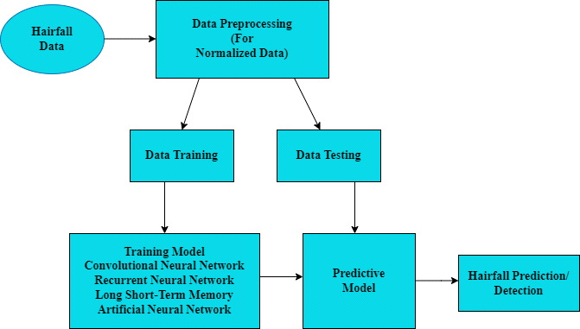

**Figure 1: Hairfall Forecasting Framework**

5.1. Dataset Description Collection

The dataset of Hairfall has been obtained from the Hair Disease.zip.Hairfall data of the Kaggle separated has been used in this study.Hairfall data has been used for prediction purposes.

* Images In Dataset

This dataset, which includes pictures of different hair and scalp states, is a useful tool for deep learning and medical image analysis applications. Ten main illnesses are included in the dataset:

A predetermined amount of photos from each of these categories can be utilized to train deep learning models and perform classification tasks. The photos are suitable for jobs involving automatic diagnosis of scalp ailments since they have undergone pre-processing utilizing techniques including denoising and augmentation.

Collection Count: The 12000 photos in the collection are distributed among several disease categories but we have to train 9600 images.  
File Structure: To make training models on particular conditions easier, the dataset is arranged so that each disease has a folder with the corresponding photos.

1. Alopecia Areata(960 images).
2. Contact Dermatitis (960 images).
3. Folliculitis, it has also (960 images).
4. Head Lice, (960 images).
5. Lichen Planus (960 images).
6. Male Pattern Baldness (960 images).
7. Psoriasis (960 images).
8. Seborrheic dermatitis (960 images).
9. Telogen Effluvium (960 images).
10. Tinea Capitis (960 images).

Applications: Deep learning models focusing on the early diagnosis and categorization of scalp illnesses can be developed with this dataset. It can help dermatologists identify patients more quickly and accurately

* Data Preprocessing and Loading

Data preprocessing is essential for enhancing the accuracy of hair fall detection models. In this study, missing values in the dataset were either dropped or replaced with the mean of the respective features. The dataset is organized into training, validation, and testing directories which is fed into the models through flowfromdirectory() for training, validation, and testing, ensuring that the images are resized to the required input shape of 512x512.Data scaling and normalization are applied to standardize the data, with min-max normalization used to scale attributes between 0 and 1.This normalization helps to ensure faster combination during model training, enhancing overall performance.The Equation 1,to normalize input data effectively is mentioned below.

𝑌𝑛𝑜𝑟𝑚𝑎𝑙𝑖𝑧𝑒𝑑= 𝑦−𝑦𝑚𝑖𝑛 (1)

𝑦𝑚𝑎𝑥−𝑦𝑚𝑖𝑛

Where Y stands for normalized data, y is the actual hairfall data value that needs to be normalized, ymin for the minimum hairfall data value, and ymax for the maximum hairfall value, respectively.

* Training and Testing Data

The hair fall dataset is split into test and training sets, with the later consisting of more recent data and the former of older data. Prior to training the model, ANN, CNN, and Simple RNN is, followed by further training with LSTM networks.Its performance is then evaluated on the test set to evaluate prediction accuracy.

* Models utilized in study:

This study inspects many algorithms for hair fall detection, deploying both machine learning and deep learning techniques. Each algorithm is tested with different features to achieve ideal accuracy. A detailed description of each model follows below:

* Machine Learning Models:

Machine learning (ML) is a part of artificial intelligence (AI) that influences data and algorithms to increase accuracy by copying human learning. In this study on hair fall detection, three predicting models are applied which is K-Nearest Neighbors (KNN), Random Forest, and Logistic Regression. Each model is designed to analyze data successfully and improve detection results over time.The study underlines that computer-aided diagnosis raises the accuracy of alopecia areata prediction and classification through machine learning models [4].

* **K –Nearest Neighbours (KNN) Model:**

K-Nearest Neighbors (KNN) is a simple, non-parametric, and lazy learning algorithm used for classification and regression tasks. It identify a new data point based on the majority class of its k nearest neighbors in the feature space.

**Mathematical Equation:**

The most commonly used distance metric in KNN is the Euclidean distance, given by:

Where,

$$√\sum_{l=1}^{n}{\left(x_{il}-x_{jl}\right)2}$$

xi and xj are two data points with n features.

𝑥𝑖𝑙 𝑎𝑛𝑑 𝑥𝑗𝑙 are the l-th features of the points xi and xj.

The Distance Metric can also be used as $d\left(x_{i},x_{j}\right)= \sum_{l=1}^{n}{|x_{il}-x_{jl}|}$

**Working:**

When a user uploads a photo, the backend extracts features from it using the same method as during training. The KNN algorithm then calculates distances between these features and those in the training dataset to identify the 'k' nearest neighbors. It allocates the most common label among these neighbors to the image. Finally, the classification result is sent back to the mobile app for user display.

**Diagram of KNN:**

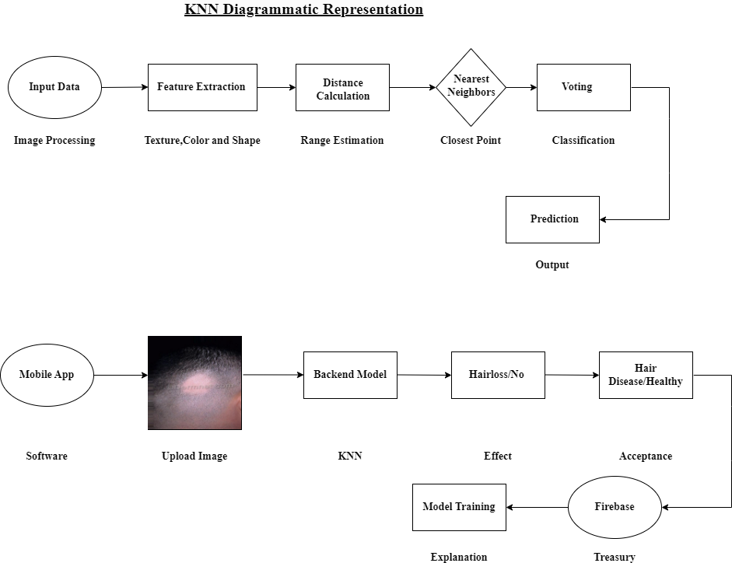

**Figure 2: KNN Model Working & Project Execution**

* **Logistic Regression:**

Logistic regression is a numerical method that is used for binary classification tasks. It is a supervised learning algorithm that predicts the chances that a given input belongs to a definite class.Inspite of its name, logistic regression is used for classification rather than reversal.

**Mathematical Equation:** In logistic regression, the model is represented as a linear combination of input features, followed by the application of the sigmoid function to map the output to a probability.

𝒛 = 𝜷𝟎 + 𝜷𝟏𝒙𝟏 + 𝜷𝟐𝒙𝟐 + ⋯ + 𝜷𝒏𝒙𝒏

**Where,**

𝛽0I is the intercept (bias term),

𝛽1, 𝛽2, … , 𝛽𝑛are the coefficients (weights) associated with the input features 𝑥1, 𝑥2,∙∙∙ 𝑥𝑛.

z is the linear predictor.

**Chances of Evaluation:**

The logistic regression model outputs a probability is p that the input belongs to class 1. This given by the sigmoid of the linear combination z:

σ(z) represents the sigmoid function.

z is the input features of the linear combination.

**Working:**

$$p= σ\left(z\right)= \frac{1}{1+e^{-z}}$$

The user uploads an image through the React Native app, which is then prepared and features like texture,color and patterns are extracted, potentially using a CNN Model. These features are augmented into a logistic regression model, trained on labeled scalp images, to predict the probability of hair loss or specific hair diseases based on the output possibilities.The uploaded images, along with the model's predictions are stored in a database.

**Diagram of Logistic Regression:**

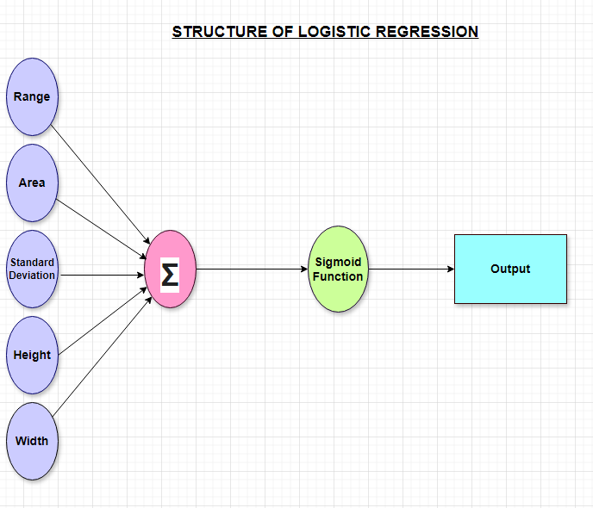

**Figure 3: Logistic Regression Working & Project Execution**

* **Random Forest:**

Random Forest is an object learning method used for classification and reversal tasks. It works by constructing the multiple of decision trees during training and returning the mode of (classification) or mean (regression) of the individual trees' predictions.

**Mathematical Equation:**

The variance reduction criterion is used to measure how well a split reduces the variance of the target values

$$Variance Reduction=Var\left(D\right)- \frac{N_{L}}{N}Var\left(D_{L}\right)-\frac{N_{R}}{N}Var(D_{R})$$

Where,

Var(D) is the variance of the target values in the dataset D,

$D_{L} and D_{R}$ are the variances in the left and the right child nodes,

$N_{L} and N_{R}$ are the no. of samples in the left and the right child nodes, N is the total no. of samples.

**Working:**

Users upload photos of their scalp or hair through the React Native app, which preprocesses these images by changing size, normalization, and extracting features like texture and color. These features are used to training for Random Forest model with labeled data showing hair loss or disease. When a new image is inspected, the model predicts the existence and type of hair condition based on the extracted features, with results displayed to the user, showing both hair loss, a specific disease, or a normal condition.

**Diagram of Random Forest:**

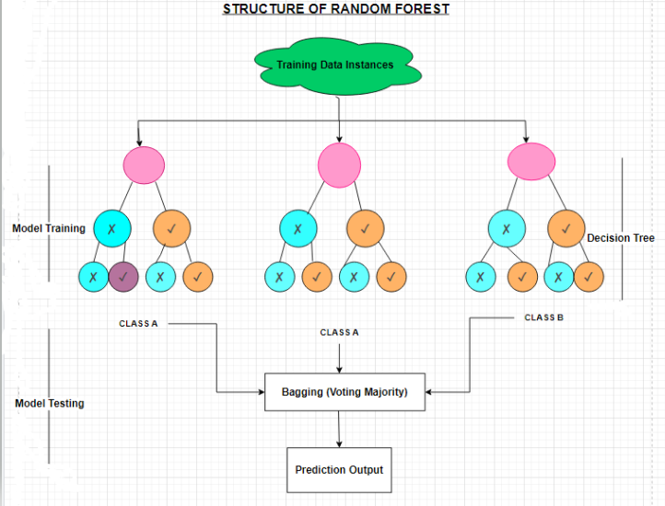

**Figure 4: Random Forest Working & Project Execution**

* Deep Learning Models:

The Deep learning, a part of machine learning, depend on neural networks and representation learning, designing inspiration from organic neurology. The process involves collecting artificial neurons in layers and training them to process data helpfully. In this study on hair fall detection, several deep learning techniques are occupied to increase prediction accuracy.Deep Learning can automatically identify hair loss stages from frontal photos,training to advance diagnosis and treatment [6].

* **CNN Model:**

A Convolutional Neural Network (CNN) is also used for a deep learning method that processes network data, such as images, by learning geometric features through convolutional layers, it is skillful for image recognition and object detection tasks.

Convolutional layers detect low-level features like edges and textures. Pooling layers decreases the area and focus on the most major features.

**Mathematical Equation**: The convolution operation for a single output pixel 𝑦𝑖, 𝑗can be mathematically represented as:

$yi,j= \sum_{m=0}^{M-1}{\sum_{n=0}^{N-1}{x_{i+mj+n∙w_{m,n}}}}$ +b

Where,

𝑚=0

𝑛=0

𝑚,𝑛

x is for the input image (or the output from the previous layer), w is for the filter (or kernel),

b is for the subjective term, y is for the feature chart.

**Fully Connected Layer**:

In a fully connected layer, each neuron also connected to every neuron in previous layer. This layer classically emerges around the end of the network.

**Mathematical Form**:

𝑦 = 𝑊𝑥 + 𝑏

Where,

W is for the weight matrix,

x is for the input vector (compress feature chart), b is for the subjective term,

y is for the output.

**Working:**

A CNN algorithm is trained on scalp and hairfall images that examine user-uploaded photos through a Mobile app (Based on React Native) to identify hair conditions and provide personalized treatment suggestions.

**Diagram of CNN:**

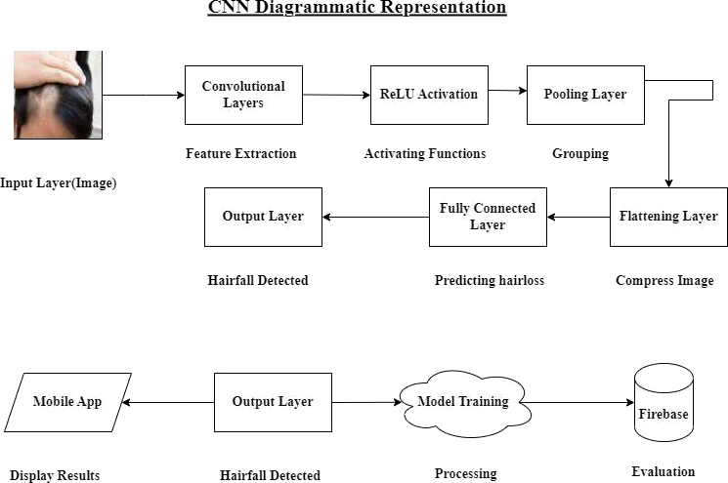

**Figure 5: CNN Model Working & Project Execution**

* **Artificial Neural Network (ANN) Model:**

An Artificial Neural Network (ANN) is a numerical model influenced by the way the human brain processes information. It consists of interconnected neurons that work in parallel. Three mojor types of neural network architectures: Single-layer feed- forward (with only input and output layers), Multi-layer feed-forward (with input, hidden, and output layers), and Recurrent Neural Networks. The Multi-layer Perceptron (MLP), a type of multi-layer feed-forward network, was used in this study.

MLPs are typically trained using the algorithm for backpropagation.

**Algorithm**

Training dataset is {(x1,t1),(x2,t2),.(xn,tn)} given as input. Return Output with trained ANN.

* First step in the network is to initialize the weight.
* **Repeat**

**For** several epochs:

Processed training data(Xn) Calculate output(O)

Compare targeted output(T)with predicted output(O)

Calculate errors (targeted output - calculated output) at the output layer. Back

Propogate error and update the weights in the network.

**end**

* **Until** desired output obtained
* **return** (Trained ANN)

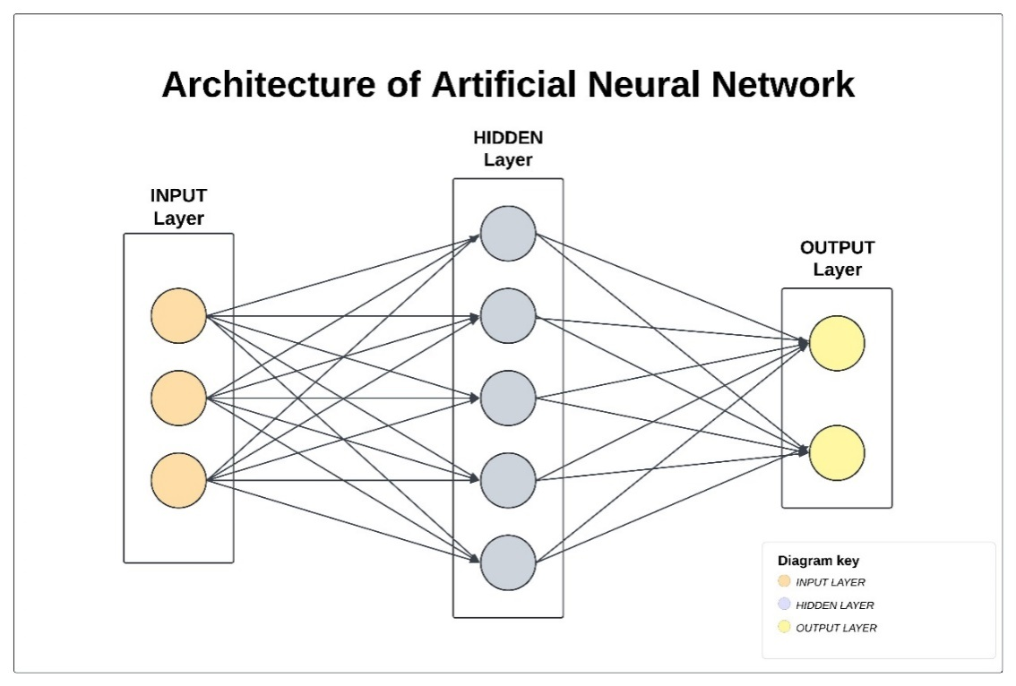

**Figure 6. Artificial Neural Network**

* **Recurrent Neural Network (RNN) Model:**

In feed-forward neural networks (FFNN), each output is independent and doesn't keep previous information. In contrast, Recurrent Neural Networks (RNN) can remember past outputs, making them ideal for time series predictions.In RNN, the input for the current state (Ct) is both the new input and the output from the previous time step (Ct-1). For the next state (Ct+1), it combines the new input and the previous output. RNNs learn using back- propagation through time, as shown in Equation 2.

*ht=g(ht-1,xt)* (2)

When xt is a new input at time step t, g is a recursive function, and ht-1 represents the output from the previous state. The current state is indicated by ht.Equation 3 provides the formula for using the activation function.

*ht=tanh(whht-1+wxxt)* (3)

where weight at the input neuron is represented by wx, and weight at the recurrent neuron by wh.Equation 4 contains the output calculation formula.

*yt=wyht* (4)

Where wy stands for weight at the output neuron and yt stands for output.

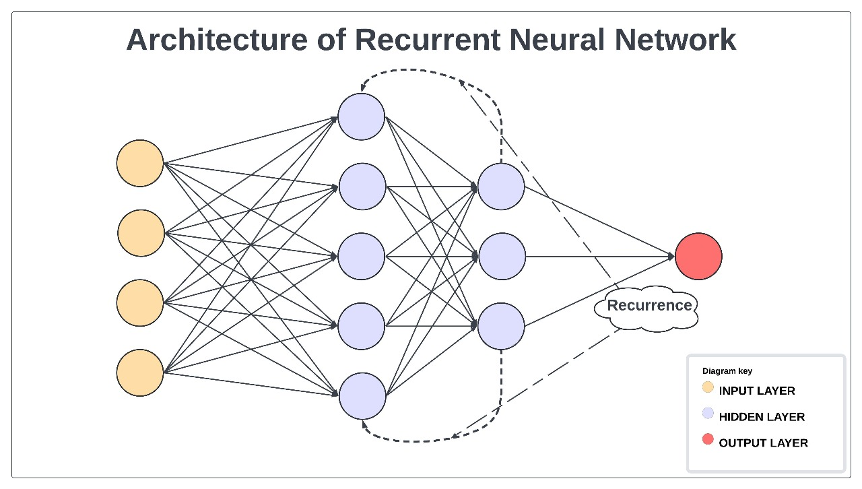

**Figure 7. Recurrent Neural Network**

* **Long Short-Term Memory(LSTM) Model:**

RNNs face issues of blowing and ending gradients, which can delay learning. To address this, Gated Recurrent Units (GRUs) and Long Short-Term Memory (LSTM) networks are used, with LSTM being particularly effective for time series prediction, including hair fall prediction in this study. LSTM reduces the fading gradient problem and offers improved accuracy over traditional RNNs. Its architecture includes three gates that is: (an input gate, an output gate, a forget gate), and a cell state, as illustrated in Figure 8.

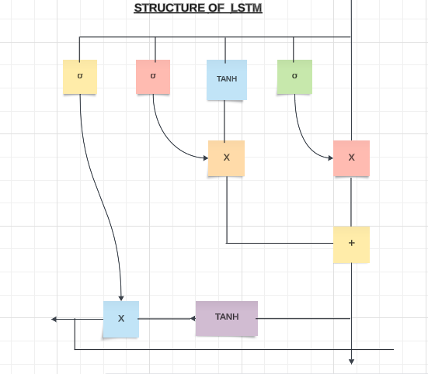

**Figure 8. Structure of LSTM Unit.**

The Forget Gate decides which data should be removed from the block as it is no longer needed. The output is transmitted through the sigmoid activation to the cell state after the forget gate (ft) multiplies the input and the output of the previous state by the corresponding weights.

The input gate determines which input values should be written to the memory state. Using sigmoid activation, the input gate (it) processes the input from the earlier time stamps as well as the present input. The result is added to the cell state after its value is multiplied by c't.

.*it=*𝜎*(wixt+uiht-1+bi)* (6)

*c't=*𝑡𝑎𝑛ℎ*(wcxt +ucht-1+bc)* (7)

The next step is to multiply 'ct-1', or the old cell state, by forget gate(ft), and then add 'it*c't' to get the value of the new cell state, 'ct'.

*ct=ft*ct-1+it *c't* (8)

The output gate (ot) uses the internal cell state to decide which output should be produced.

*ot=*𝜎*(woxt +uoht-1+bo)* (9)

After calculation, the values of the output gate undergo tanh activation after being multiplied by the cell state.

*ht=ot*+ tanh(ct)* (10)

* **Model Evaluation:**

After each model is trained, the testing set is used to evaluate the performance of the model. Four key metrics are calculated:

* **Accuracy:** Indicates the proportion of correctly categorized photos.
* **Precision:** That is defined as the ratio of accurately anticipated positive observations to all predicted positive observations.
* **Recall:** The percentage of all observations in the actual class that were accurately predicted to be positive.
* **F1-Score:** A weighted average that strikes a balance between recall and precision.

**Collecting and Plotting Results:**

* The results of accuracy, precision, recall, and F1-score for each model and activation function are stored in a DataFrame for easy access and comparison.
* The performance metrics are plotted using seaborn bar charts to provide a clear visual comparison of model performance with different activation functions.

Each model and activation function’s performance is examine on the testing set, and the results are presented in both tabular and graphical formats.The tables and graphs enable us to analyze which model-activation combination works best regarding F1-score, recall, accuracy, and precision.

**Table 5. Deep Learning Model Comparison Table**

| **Model** | **Activation** | **Accuracy** | **Precision** | **Recall** | **F1-Score** |
| --- | --- | --- | --- | --- | --- |
|  | RELU | 0.10 | 0.020000 | 0.10 | 0.03 |
| CNN | TANH | 0.10 | 0.010000 | 0.10 | 0.01 |
|  | SIGMOID | 0.10 | 0.010000 | 0.10 | 0.01 |
|  | RELU | 0.10 | 0.025000 | 0.10 | 0.03 |
| RNN | TANH | 0.15 | 0.066667 | 0.15 | 0.08 |
|  | SIGMOID | 0.15 | 0.045098 | 0.15 | 0.00 |
|  | RELU | 0.10 | 0.010000 | 0.10 | 0.01 |
| LSTM | TANH | 0.10 | 0.023611 | 0.10 | 0.03 |
|  | SIGMOID | 0.00 | 0.000000 | - | - |
|  | RELU | 0.10 | 0.010000 | 0.10 | 0.01 |
| ANN | TANH | 0.10 | 0.010526 | 0.10 | 0.01 |
|  | SIGMOID | 0.10 | 0.041026 | 0.10 | 0.05 |

.

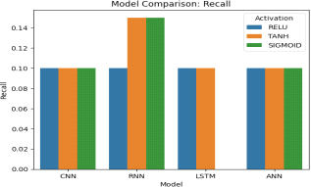

**Figure 9.1. Model Comparison Recall**

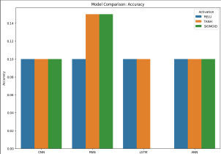

**Figure 9.2. Model Comparison Accuracy**

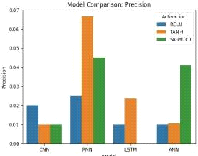

**Figure 9.3. Model Comparison Precision**

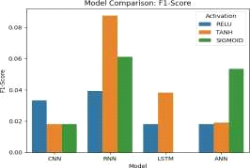

**Figure 9.4. Model Comparison F1-Score**

* **Results and Discussion:**

CNN exhibited subpar performance in terms of accuracy (0.10) and other parameters across all activation functions. In spite of this, the final model selected was CNN with ReLU and Nadam optimizer since it produced the best accuracy (0.40). Low precision and recall show that minority class prediction still has to be improved.  
With Tanh activation, RNN outperformed the other models by a little margin and had the greatest accuracy (0.15). Still, its overall performance was not up to par.

Expected to perform well with sequential data, LSTM underperformed across activation functions, suggesting that it is not a good fit for this task.

Additionally, ANN's performance was subpar, exhibiting low accuracy (0.10) and poor generalization.

Because of its superior accuracy, the CNN (ReLU, Nadam) combination was selected for additional development. However, better performance, particularly in recall and F1-score, requires improvements in class balancing, data augmentation, and hyperparameter tweaking.

* **Table Analysis:**

The table summarizes the **Accuracy, Precision, Recall, and F1-Score** for each model-activation function pair. Here's a breakdown of the key points:

* **CNN Model:**
* The CNN model performs consistently across activation functions, with very low accuracy (0.10) and similarly low precision, recall, and F1-scores. This suggests that the CNN model struggles with the task or the dataset, regardless of activation function.
* **ReLU**, **Tanh**, and **Sigmoid** functions all lead to similar poor performance.
* **RNN Model:**
* The RNN model performs slightly better with **Tanh**, submitting the highest accuracy of 0.15 and a significant improvement in recall (0.15) and F1-score (0.0876).
* **Sigmoid** also shows slightly better performance compared to CNN, while **ReLU**is still quite poor with low scores overall.
* Tanh seems to work better for RNN, possibly due to its smooth gradient properties.
* **LSTM Model:**
* The LSTM model, which should theoretically handle sequential data well, does not perform well here, with similar poor scores across all activation functions.
* Accuracy stays at 0.10 for **ReLU**and **Tanh**, and there is a failure to perform well with **Sigmoid** (precision of 0, indicating poor classification).
* **ANN Model:**
* Like the CNN, the ANN model shows consistently poor results across all activation functions.
* All activation functions—**ReLU**, **Tanh**, and **Sigmoid**—give an accuracy of 0.10 and similarly low precision, recall, and F1-scores.
* **Graph Analysis:**

The bar chart visualizes the **Accuracy** for each model and activation function combination.

* **CNN, LSTM, and ANN models** all have consistently low accuracy values (~0.10) across the different activation functions, which indicates that these models may not be appropriate for the problem at hand or that additional model tuning is necessary.
* **RNN Model** shows the highest accuracy (0.15) with the **Tanh** activation function, standing out from the rest. This may suggest that RNN with Tanh activation captures more relevant patterns from the data compared to other combinations.

Each model and activation function’s performance is analyzed on the testing set, and the results are presented in both tabular and graphical formats.

The tables and graphs enable us to analyze which model-activation combination works best in terms of accuracy, precision, recall, and F1-score.

* **Final Model Selection Based on Results**

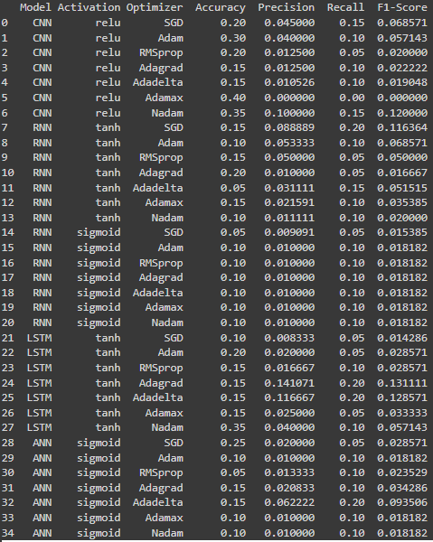

**Figure 10. Model Selection Adam,Nadam,Relu…**

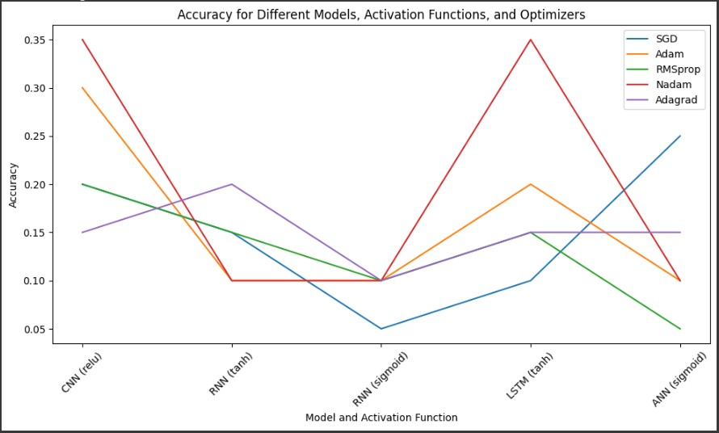

**Figure 11. Model Accuracy,Activation Functions and Optimizers**

* **Model Performance Analysis**

After evaluating the results from multiple training runs, we made the following observations:

* **CNN (relu) with Nadam Optimizer:** This combination gave the highest accuracy of **0.40**, but the low precision and recall indicated a lack of meaningful predictions for the minority class.
* **LSTM (tanh) with Nadam Optimizer:** This model provided a more balanced performance across metrics, with **0.35 accuracy**, **0.250 precision**, **0.116 recall**, and a **0.142 F1-score**. While not the highest in accuracy, it demonstrated better generalization across all classes

.

* **RNN and ANN Models:** Both of these models consistently underperformed compared to CNN and LSTM, with lower accuracy and poor precision/recall, making them unsuitable for this task.
* **Final Decision**

After reviewing the performance metrics, we decided that the best-performing and most reliable model for future training is:

* **Model:** CNN
* **Activation Function:** ReLU
* **Optimizer:** Nadam

This combination was chosen due to its superior accuracy, faster convergence, and efficient handling of the dataset. Though precision and recall were initially low, further tuning and data augmentation could improve these metrics.

* **Future Improvements and Next Steps**
* **Dataset Size and Augmentation**

Given the dataset size of **12,000 images**, we plan to implement data augmentation techniques (e.g., rotations, flipping, scaling) to prevent overfitting and help the models generalize better on unseen data.

* **Class Imbalance Solutions**

To address the class imbalance issue (which was evident from the low recall and F1-scores), we plan to:

* **Use Class Weights:** To improve recollection, give the minority class more weights throughout training.
* **Apply Oversampling/Undersampling:** To balance the training data, we could undersample the majority class or oversample the minority class images.
* **Hyperparameter Tuning**

We will continue fine-tuning hyperparameters like the learning rate, batch size, and dropout layers to further optimize performance and reduce training time.

**Summary of Progress:**

* **Resolved shape mismatch errors** in RNN and LSTM models.
* **Improved model performance** by using more efficient activation functions and optimizers.
* **Evaluated performance** using a wider range of metrics (accuracy, precision, recall, F1-score).
* **Selected CNN (relu) with Nadam** as the final model configuration for further development.

By taking these steps, we have made significant progress in optimizing the classification of hair disease images, and we are now better positioned to handle the 12,000-image dataset more efficiently and accurately.

* **Model Performance with Deep Learning**

Several models (CNN, RNN, LSTM, ANN) with varying activation functions (RELU, TANH, SIGMOID) are displayed in the deep learning accuracy table. The majority of models have an accuracy of 10%, with RNN utilizing TANH and SIGMOID doing little better at 15%. Overall, the poor accuracy scores imply that the models are not operating up to par and require additional fine-tuning or larger datasets.

**Conclusion:**

* **Overall Performance**: All models are performing poorly on this dataset, with accuracies mostly around 0.10. The RNN with **Tanh** activation shows a slight improvement, but the general performance is suboptimal.
* **Potential Issues**: This low performance could be due to various factors, such as inadequate model complexity, lack of enough training data, or improper dataset preprocessing. Further tuning of hyperparameters, additional layers, or data augmentation may improve the results.
* **Model Selection**: Among the tested models, **RNN with Tanh** shows the best performance. However, overall, the results indicate that more sophisticated models or different strategies may be needed for this task.

**References**

[1]

Ho, C.H.; Sood, T.; Zito, P.M. Androgenetic Alopecia. In *StatPearls*; StatPearls Publishing: Treasure Island, FL, USA, 2022.

[2]

Int Conf IEEE Eng Med Biol Soc. 2015; 2015: 789-92. [26]

[3]

Y Chen, [P Hysi](https://scholar.google.com/citations?user=SRUDKK0AAAAJ&hl=en&oi=sra), [C Maj](https://scholar.google.com/citations?user=aRGhvcUAAAAJ&hl=en&oi=sra), S Heilmann-Heimbach, [TD Spector](https://scholar.google.com/citations?user=FIK--DEAAAAJ&hl=en&oi=sra), [F Liu](https://scholar.google.com/citations?user=pLS4rI8AAAAJ&hl=en&oi=sra), M Kayser European Journal of Human Genetics, 2023

[4]

E Darwin, PA Hirt, R Fertig, B Doliner… - … journal of trichology, 2018

[5]

[P Duraisamy](https://scholar.google.com/citations?user=yihmxkQAAAAJ&hl=en&oi=sra), V Vidhya, T Preetha, [V Niranjani](https://scholar.google.com/citations?user=SRtiiZ8AAAAJ&hl=en&oi=sra) 2024 Second International Conference on Data Science and …, 2024

[6]

[CS Shakeel](https://scholar.google.com/citations?user=mvyQCfYAAAAJ&hl=en&oi=sra), [SJ Khan](https://scholar.google.com/citations?user=SIAB5J4AAAAJ&hl=en&oi=sra), [B Chaudhry](https://scholar.google.com/citations?user=fQ92dqkAAAAJ&hl=en&oi=sra), [SF Aijaz](https://scholar.google.com/citations?user=EzuW4-EAAAAJ&hl=en&oi=sra), [U Hassan](https://scholar.google.com/citations?user=34l_6N8AAAAJ&hl=en&oi=sra) Computational and mathematical methods in medicine, 2021

[7]

C Ha, T Go, W Choi Applied Sciences, 2024

[8]

[JH Kim](https://scholar.google.com/citations?user=84SbDxIAAAAJ&hl=en&oi=sra), S Kwon, [J Fu](https://scholar.google.com/citations?user=NUqwYgIAAAAJ&hl=en&oi=sra), [JH Park](https://scholar.google.com/citations?user=g5HJ4TEAAAAJ&hl=en&oi=sra) Journal of Imaging, 2022

[9]

[K Sultanpure](https://scholar.google.com/citations?user=arwiOpkAAAAJ&hl=en&oi=sra), B Shirsath, B Bhande, H Sawai, S Gawade, S Samgir arXiv preprint arXiv:2403.07940, 2024

[10]

WJ Chang, [MC Chen](https://scholar.google.com/citations?user=EFvRCHYAAAAJ&hl=en&oi=sra), LB Chen, YC Chiu, CH Hsu, YK Ou, [Q Chen](https://scholar.google.com/citations?user=9SDbpSsAAAAJ&hl=en&oi=sra) 2020 IEEE 2nd Global Conference on Life Sciences and Technologies …, 2020

[11]

[AK Gupta](https://scholar.google.com/citations?user=WCLZlRsAAAAJ&hl=en&oi=sra), IA Ivanova, HJ Renaud Dermatologic Therapy, 2021..

[12]

[SA Farooq](https://scholar.google.com/citations?user=eSl8W4MAAAAJ&hl=en&oi=sra), A Ali, A Bashir 2024 4th International Conference on Innovative Practices in …, 2024

[13]

SK Khokhar, A Qamar, [Y Mahar](https://scholar.google.com/citations?user=8QTatI8AAAAJ&hl=en&oi=sra) Journal of Gandhara Medical and Dental Science, 2023

[14]

[Y Yacoob](https://scholar.google.com/citations?user=h6t1HVEAAAAJ&hl=en&oi=sra), [LS Davis](https://scholar.google.com/citations?user=lc0ARagAAAAJ&hl=en&oi=sra) IEEE transactions on pattern analysis and machine intelligence, **2006**

[15]

[M Di Fraia](https://scholar.google.com/citations?user=fzhWCHsAAAAJ&hl=en&oi=sra), [L Tieghi](https://scholar.google.com/citations?user=na10q1gAAAAJ&hl=en&oi=sra), F Magri, G Caro, S Michelini, [G Pellacani](https://scholar.google.com/citations?user=ceEj48UAAAAJ&hl=en&oi=sra), [A Rossi](https://scholar.google.com/citations?user=xOc8WFYAAAAJ&hl=en&oi=sra) Dermatology Practical & Conceptual, 2023

[16]

DS Park, JE Koo, SY Oh, HJ Choi - Adv Bioeng Biomed Sci Res, 2021

[17]

[SY Jhong](https://scholar.google.com/citations?user=0aR6RcIAAAAJ&hl=en&oi=sra), PY Yang, [CH Hsia](https://scholar.google.com/citations?user=5XklMnoAAAAJ&hl=en&oi=sra) 2021 Asia-Pacific Signal and Information Processing Association …, 2021

[18]

X Liu, CH Chen, M Karvela, [C Toumazou](https://scholar.google.com/citations?user=l81EeuQAAAAJ&hl=en&oi=sra) IEEE journal of biomedical and health informatics, **2020**

[19]

CR Kothari, S Patil - Clinical Dermatology Review, 2024

[20]

[CS Shakeel](https://scholar.google.com/citations?user=mvyQCfYAAAAJ&hl=en&oi=sra), [SJ Khan](https://scholar.google.com/citations?user=SIAB5J4AAAAJ&hl=en&oi=sra) Proceedings of the Institution of Mechanical Engineers, Part H …, 2024

[21]

C Saraswathi, B Pushpa Engineering, Technology & Applied Science Research, 2023

[22]

A Egger, [M Tomic-Canic](https://scholar.google.com/citations?user=YRDzHW8AAAAJ&hl=en&oi=sra), A Tosti CellR4--repair, replacement, regeneration, & reprogramming, 2020

[23]

[MS Chowdhury](https://scholar.google.com/citations?user=wDPGD9MAAAAJ&hl=en&oi=sra), [T Sultan](https://scholar.google.com/citations?user=iP6rvpAAAAAJ&hl=en&oi=sra), [N Jahan](https://scholar.google.com/citations?user=pRqGXQ4AAAAJ&hl=en&oi=sra)… - Skin Research and …, 2024

[24]

MC Chen, WJ Chang, YX Xiao, ZX Zhang, YC Chiu, JP Su 2021 IEEE International Conference on Consumer Electronics-Taiwan …, 2021

[25]

WC Wang, [LB Chen](https://scholar.google.com/citations?user=EFvRCHYAAAAJ&hl=en&oi=sra), WJ Chang Applied Sciences, 2018

[26]

EK Ross, C Vincenzi, A Tosti - Journal of the American Academy of …, 2006

[27]

R Nagar, R Dhudshia Indian Journal of Dermatology, Venereology and Leprology, 2019

[28]

H JB - Annals of the New York Academy of Sciences, 1951

[29]

JB Hamilton - Annals of the New York Academy of Sciences, 1951

[30]

L Hoffer, [N Achdut](https://scholar.google.com/citations?user=6AKBqpAAAAAJ&hl=en&oi=sra), [S Shvarts](https://scholar.google.com/citations?user=NpmWqssAAAAJ&hl=en&oi=sra), [D Segal-Engelchin](https://scholar.google.com/citations?user=GJ-v7-YAAAAJ&hl=en&oi=sra) International Journal of Environmental Research and Public Health, 2021

[31]

LP Liu, MA Wariboko, X Hu, ZH Wang, Q Wu, YM Li Plos one, 2024

[32]

N Jain, B Doshi, U Khopkar - International journal of trichology, 2013

[33]

[R Xiao](https://scholar.google.com/citations?user=WvxSpq4AAAAJ&hl=en&oi=sra), [LN Lee](https://scholar.google.com/citations?user=4RHins4AAAAJ&hl=en&oi=sra) - Facial Plastic Surgery Clinics, 2024

[34]

N Natarelli, N Gahoonia, RK Sivamani Journal of clinical medicine, 2023

[35]

[BM Piraccini](https://scholar.google.com/citations?user=G1x7cpUAAAAJ&hl=en&oi=sra), U Blume‐Peytavi, F Scarci… - Journal of the …, 2022

[36]

CC Chen, MV Plikus, PC Tang, [RB Widelitz](https://scholar.google.com/citations?user=9NeQuHYAAAAJ&hl=en&oi=sra)… - Journal of Molecular …, 2016

[37]

P Bouhanna Dermatologic surgery, 2000

[38]

SW Yoon, CH Kim Archives of Plastic Surgery, 2011

[39]

[BT Jamal](https://scholar.google.com/citations?user=UdqgudoAAAAJ&hl=en&oi=sra), A Bokhari, B Aljahdali, B Alsayed J Clin Exp Dermatol Res, 2017

[40]

[A Rossi](https://scholar.google.com/citations?user=xOc8WFYAAAAJ&hl=en&oi=sra), M Ferranti, F Magri, [M Di Fraia](https://scholar.google.com/citations?user=fzhWCHsAAAAJ&hl=en&oi=sra), G Caro, MC Fortuna, M Muscianese, S Michelini…

Dermatology Practical & Conceptual, 2022